FOR IMMEDIATE RELEASE
Media Contact: Drew Persson

STOP POLISHING WITH SAND
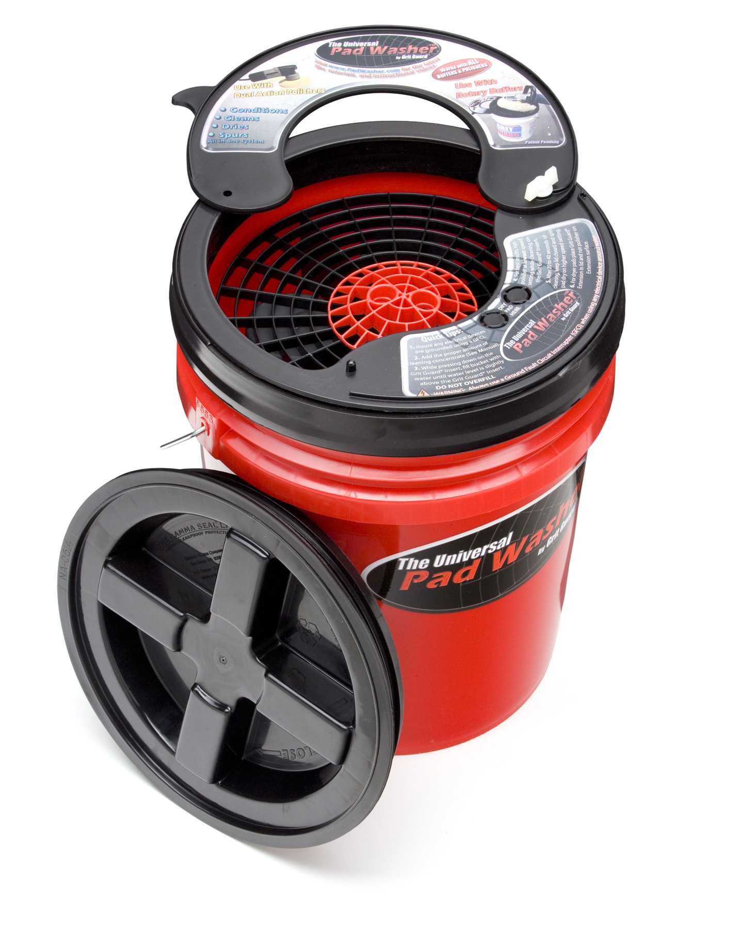
Bellefontaine, OH: No doubt you’re noticed lots of swirl marks in the paint on your car, truck, motorcycle or boat. Worse, the fine scratches don’t go away no matter how much time and money you spend trying to buff them out, or what kind of polish you use. News flash; the problem is actually sand or grit in your buffing pad, which cuts new swirl marks every time you sand away yet another layer of your expensive paint.
But don’t despair, buffing pads can be easily cleaned and reused with the right equipment. Check out the patent-pending Universal Pad Washer (UPW) from the cleaning experts at Grit Guard™, who stuffed a whole lot of pad-scrubbing technology into a portable five-gallon container. Simply fill the UPW system with water and mist your dirty pad with Grit Guard™ Pad Renewing Solution. Massage the pad against the articulating Grit Guard™ Insert in the UPW while operating the buffer at low speed. Lift slightly to spin dry, then remove from the UPW and go back to buffing with a thoroughly-clean and refreshed pad. All in less time than it would take to attach a new pad to your buffer. And it works with practically ANY type of pad or buffer – including professional dual-head models, large and small orbital buffers, and even foam ball polishers attached to power drills.
Here’s how it works: lurking beneath the easy-off leak-proof threaded Gamma-Seal lid (great for mobile detailers or show competitors) is a patented Grit Guard™ cleaning insert positioned atop four spring-loaded mechanical water pumps. Pushing the Grit Guard™ Insert downward with the buffer pumps jets of clean water upward into the pad, vigorously flushing away embedded grit, oxidized paint and used polishing compounds. These abrasive contaminants settle and become trapped below the pump support base, where they can no longer damage your paint. There’s also high-speed pumping and flushing action as the spinning pad rubs its fibers and pores against the ribs of the Grit Guard™ Insert, rapidly alternating between being rung out and absorbing fresh water. And the Universal Pad Washer isn’t just a pad cleaner; it converts into the classic Grit Guard™ Washing System just by removing the pump assembly, so the UPW is really two car care products in one.
Visit www.PadWasher.com for more info and to see videos of the Universal Pad Washer in action, or call Grit Guard™ at 866-592-5925. Grit Guard, 3690 County Road 10, Bellefontaine, OH 43311
•••
Download high-res image: http://www.mediaturbo.com/media/gritguard/gg0807.jpg
Download release PDF: http://www.mediaturbo.com/media/gritguard/gg0807.pdf
View online: http://www.mediaturbo.com/media/gritguard/gg0807.html

